Plagues, Witches, and War: A MOOC Postmortem

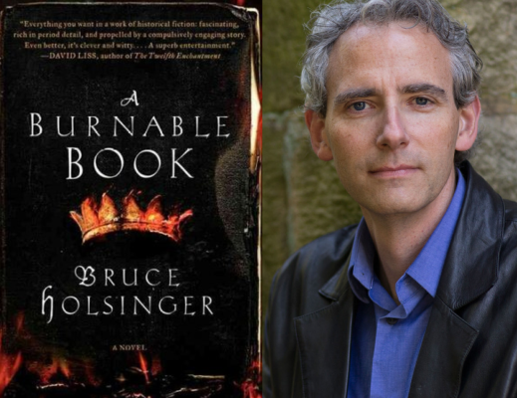

Bruce Holsinger
(Fiction Writer and Professor of English, University of Virginia)

Sponsored by the GW Digital Humanities Institute, in coordination with the
GW Medieval and Early Modern Studies Institute, English, and Creative Writing

Date: Friday, December 5
Time: 7 PM (includes talk followed by Q&A)
Place: Marvin Center Amphitheater, George Washington University

Drawing from a case study at the University of Virginia, this lecture explores the controversies, university politics, and economic challenges surrounding the emergence of Massive Open Online Courses (MOOCs) over the past few years.

Bruce Holsinger is a fiction writer and literary scholar at the University of Virginia. His critically-acclaimed debut novel, A Burnable Book, and its forthcoming sequel, The Invention of Fire (William Morrow/HarperCollins), are set in the alleys and halls of medieval London. His nonfiction books have won major awards from the Modern Language Association, the Medieval Academy of America, and the American Musicological Society, and his research has been supported with fellowships from the National Endowment for the Humanities, the American Musicological Society, and the Guggenheim Foundation. He appears regularly on National Public Radio and has written for The Washington Post, The Nation, The Chronicle of Higher Education, and other publications.
For more info, contact Jonathan Hsy (jhsy@gwu.edu) or visit www.gwdhi.org.

